**ISM Summer Research Write-Up**

This summer, I used many statistical and analytical methods to further probe the GASKAP-HI LMC and SMC data, so as to characterize the structure and formation of the molecular clouds.

I first investigated filamentary/small-scale HI using the Fourier Transform and unsharp mask (Figure 1), and correlated this with the molecular hydrogen using two methods. The first involved integrating the HI over multiple channel maps—in channel spacings of 3 km/s—and correlating this with all H2 data available; the second involved using HI velocities (± 3 km/s) corresponding to H2 sightlines that have central velocities. The H2 velocities were substituted with carbon and chlorine ones, so this second method had fewer H2 sightlines, but presumably greater accuracy. 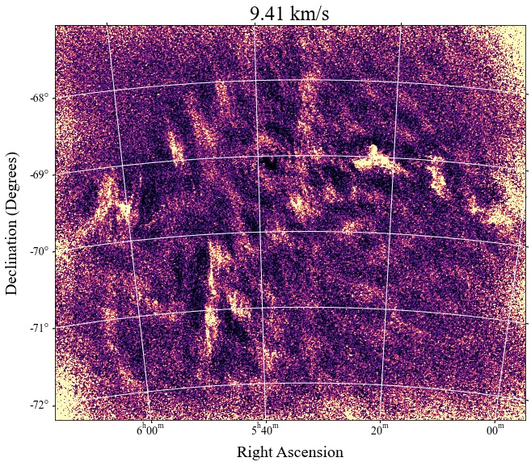

***Figure 1:*** *An LMC channel map with the unsharp mask applied on top*

A strong upwards correlation unfortunately does not exist between the H2 and the total, large-scale, or small-scale HI—future quarters will tell us whether this is due to telescopic artifacts contaminating the data (Figure 2). However, there is most definitely evidence for filamentary HI in this region of sky, and seeming evidence that it could be correlated with the CNM, based upon Kalberla et al 2016. When I created a cube of the small-scale HI, the HI varied greatly between channel maps, with the narrow channel map spacing in the cube corresponding to a narrow line width of the HI, indicating CNM gaseous temperatures.

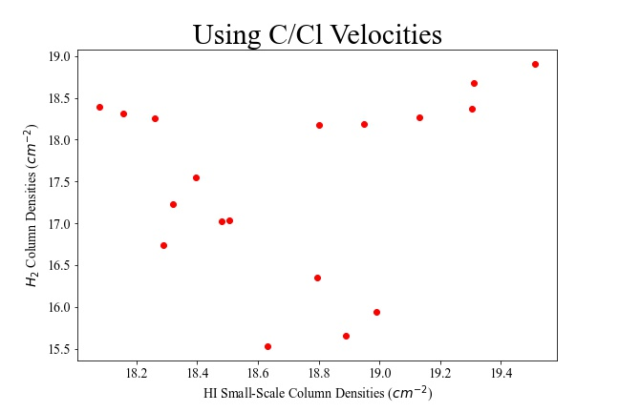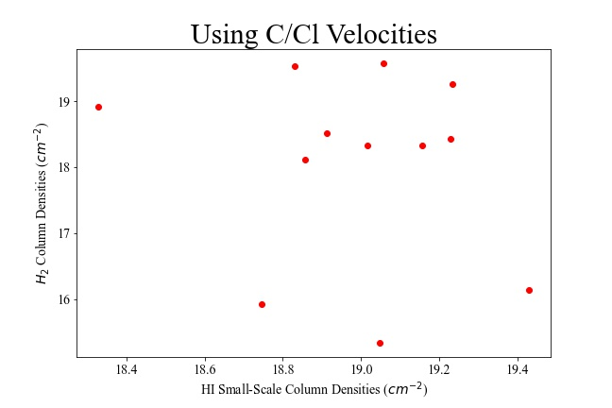

***Figure 2:*** *Small-scale HI vs H2 at specific adsorber velocities, with carbon and chlorine velocity measurements substituted in for the H2. Left is LMC, right is SMC.*

The analytical lack of correlation between HI and H2 is not unique to GASKAP, though; when correlating GASKAP data with HI4PI data from the same region of sky—I mosaicked 4 HI4PI subcubes together—the HI4PI data correlated well with the GASKAP-HI data, and also had an odd lack of correlation between the total, large-scale, and small-scale HI with the H2. (I had to ensure that the GASKAP and HI4PI data were at the same angular resolution, though, by weakening the GASKAP resolution.)

I also began using statistical methods to infer the scale of these molecular clouds; specifically, by calculating structure functions. In the LMC, the small-scale HI seems to be around 0.3 degrees in scale, large-scale HI around 1 degree, and the H2 around 0.6 degrees (Figure 3). In the SMC, the small-scale HI seems to be around 0.4 degrees in scale, large-scale HI around 0.2 degrees, and the H2 around 0.3 degrees. We defer a deeper investigation of structure functions to another quarter.

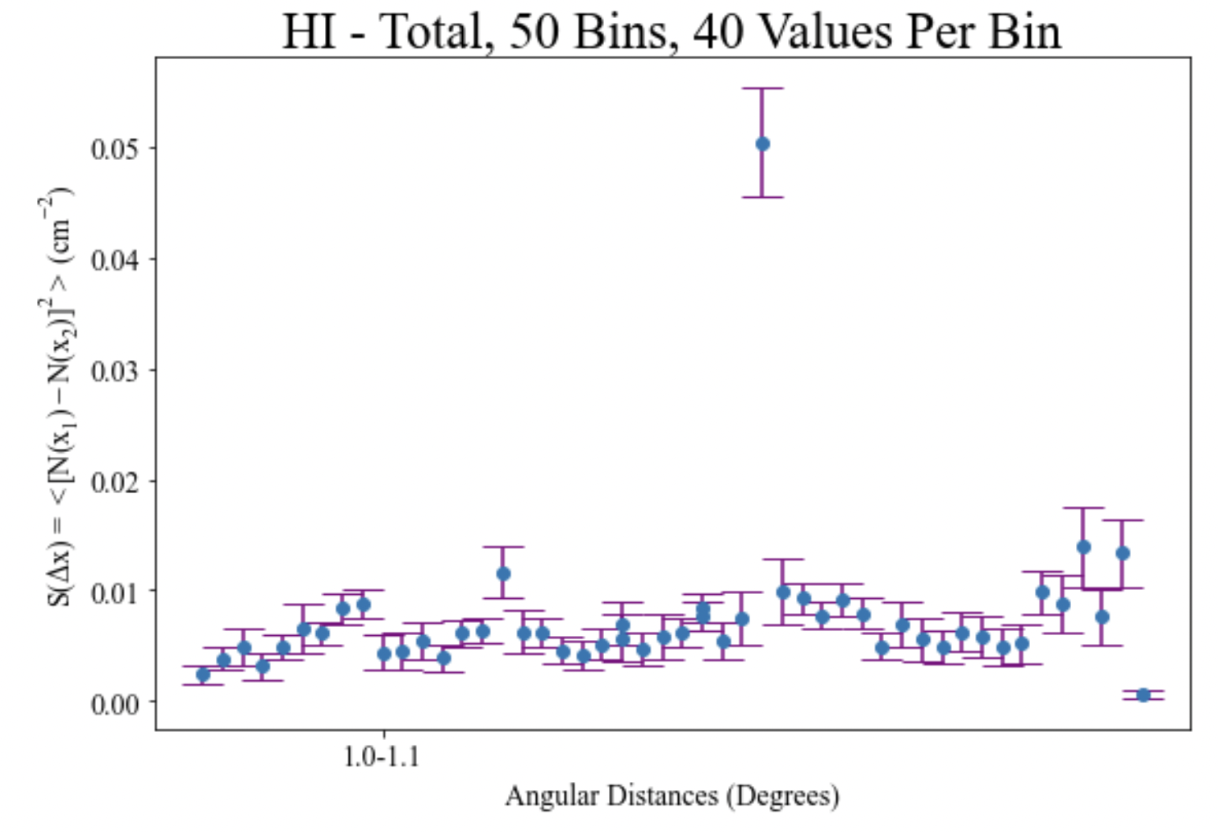

***Figure 3:*** *LMC structure function using total HI column density values at H2 sightlines*

Lastly, because we are considering using these data to estimate dust polarization from the Magellanic System itself, I used the Rolling Hough Transform to create preliminary Stokes Q and U maps with the data (Figure 4). I initially struggled with configuring Sherlock to perform the RHT—since the RHT is computationally expensive—but my main takeaway was to use Sherlock On-Demand instead. (Avoid the terminal!) Also, all packages must be imported to Sherlock beforehand.

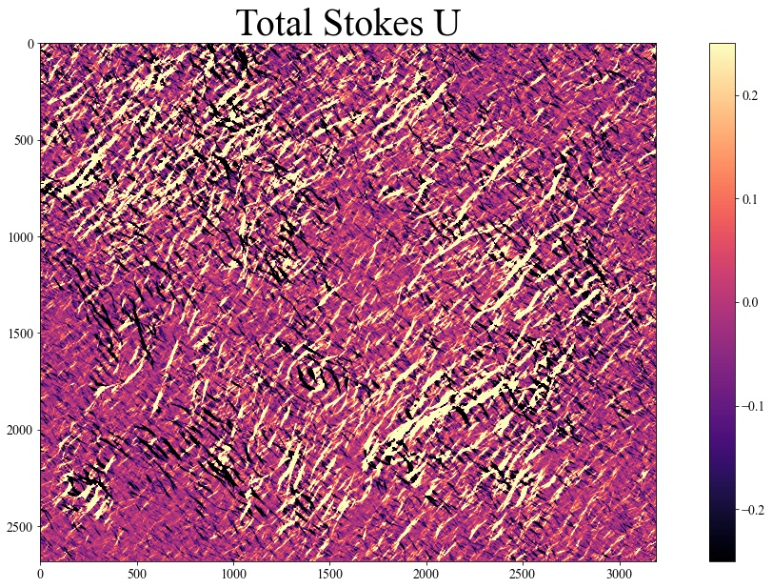

***Figure 4:*** *Stokes U map for the LMC, using data from all velocities with noticeable emission*

Future directions for this project include adding more GASKAP collaborators, cleaning the data further—and verifying results with the HI4PI survey—and performing more analysis with structure functions and the dust polarization from the Magellanic System.

Beyond performing research, this summer also gave me the perfect opportunity to do much reading on the ISM, filamentary HI, Galactic magnetic fields, molecular clouds, absorption line measurements, and the Fourier Transform. I tried to read at least 1 paper daily—which proved relatively easy to do while waiting for code to run—and read through many informative textbooks as well, including *Essential Radio Astronomy* (Condon), *Synthesis Imaging in Radio Astronomy* (Perel et al.), *Physics of the ISM* (Draine), *Astronomical Spectroscopy* (Tennyson), *Measurements and their Uncertainties* (Hughes and Hase), *ISM and IGM* (Ryden and Pogge), *A PhD is Not Enough* (Feibelman). Overall, I have a much improved grasp on the bigger picture behind my research, and on where it sits relative to other current and previous literature.

I’ve enjoyed integrating within a larger scientific community too, and KIPAC Tea Talks have been particularly enjoyable, as has MASS, PUWMAS lunches, working with Kirill, becoming more familiar with other graduate students in KIPAC and in our group, and learning how to present my own research and that of others (eg: when I presented De Cia et al 2021 at Tea). Before this summer, I had also naively organized all my code in one large Jupyter Notebook, and that finally broke down mid-July when my computer had had enough. So this summer also made me meticulously organize my code!

Overall, this summer affirmed my want to continue doing research, and to pursue a physics major. It’s great seeing concepts from my courses in actual research; many topics in E&M, and specifically their applications, make much more sense to me now. I’m currently planning on going to graduate school, and hoping to pursue other avenues of physics research in the future to see what else I might be interested in. But, all in all, I’ve had a fantastic summer!

[**NOTES**](https://drive.google.com/drive/folders/1oVBXCuDjD1NzSE38GDcBrkPXSa7orvw2?usp=sharing)

[**CODE**](https://drive.google.com/drive/folders/18a0UBZluABsBKZ3RaCJyd3bYINNzd-yZ?usp=sharing)